A Comparative Analysis of Training Techniques for Vertebral Segmentation Using RSNA2022

1 Introduction

The cervical spine is a dynamic structure tasked with protecting nervous innervation to the entire body while also maintaining a range of motion for the head and neck [1]. Fractures of the cervical spine are a leading cause of mobility and mortality in trauma patients, and a bone fracture is associated with 56% of cervical spinal cord injuries [2]. Computed tomography (CT) has become the primary imaging modality for spine assessment as its high spatial resolution, yet the manual interpretation of these scans contributes to an already overwhelming radiologist workload, with a 2024 poll reporting burnout in 44% of male and 65% of female radiologists and some studies exceeding 80% [3][4]. In the context of acute traumatic spinal cord injury, this pressure is further compounded by mounting evidence that earlier surgical decompression, within 24 hours and potentially as short as 8 to 12 hours, yields superior neurological outcomes, leaving little margin for delayed assessment [5]. Such demands have become a key motivation for developing automated clinical decision support system capable of assisting radiologists in timely assessment.

Recent advances in deep learning have driven significant progress in the automated analysis of spinal CT images. Several public datasets have been released to facilitate reproducible research in this domain, with the RSNA 2022 Cervical Spine Fracture dataset standing out as one of the most widely adopted benchmarks [6]. This dataset provides large-scale, multi-institutional CT scans with detailed annotations, including multi-class labels for seven cervical vertebrae (C1–C7) and additional labels covering thoracic vertebrae (T1–T12), offering significant potential for all classification, object detection and segmentation research.

Despite the availability of vertebral segmentation annotations in RSNA 2022, most existing studies primarily exploit these labels as auxiliary information for object detection or vertebrae identification rather than addressing vertebral segmentation as a standalone task. To address this gap, our work focuses on investigating how to effectively utilize this dataset for vertebral segmentation task. This study presents a comparative study of multiple deep learning segmentation approaches applied to the RSNA 2022 dataset, investigating how different architectural choices and training strategies influence vertebral segmentation performance. Our study examines the following research questions:

RQ1: How do HU normalisation and data augmentation affect U-Net based vertebral segmentation model performance on RSNA 2022 Dataset?
RQ2: How do different model spatial architectures affect U-Net based vertebral segmentation model performance on RSNA 2022 Dataset?
RQ3: How do different loss functions affect U-Net based vertebral segmentation model performance on RSNA 2022 Dataset?

2 Related Work

Multiple deep learning–based segmentation models have been proposed for vertebral analysis in CT imaging. However, the majority of these approaches rely on private clinical datasets that are relatively small in scale. While such datasets often contain high-quality annotations, their limited size and restricted availability pose challenges for broader validation and generalisability across diverse patient populations, imaging protocols, and clinical conditions. Sekuboyina et al. (2018) [7] introduced a data-driven spine segmentation framework combining attention-based localisation and a U-Net–style segmentation network. Their model achieved mean Dice coefficients of 87.60% and 85.91% for healthy and fractured private cases respectively, and 92.1% and 83.7% for healthy and osteoporotic subjects on the public dataset, demonstrating strong performance on both private and small public datasets though still revealing sensitivity to unseen fracture types and structural inconsistencies at scan boundaries. Subsequently, Sha et al. (2020) [8] applied a standard 2D U-Net to segment spinal fracture lesions using privately collected hospital data, including 40 spinal fracture cases from Xijing Hospital. Their model achieving an average segmentation accuracy of 87.9% though still suffering from notable false positives and false negatives due to complex fracture patterns and limited training samples. In the follow-up study, Sha et al. (2021) [9] improved their approach by incorporating dilated convolutions and attention mechanisms, training on 30 cases of spinal CT images collected from Xijing Hospital and other medical facilities, achieving an accuracy of 0.986 and a Dice similarity score of 0.977 with an inference time of only 13 ms per image compared to 23 ms for a standard U-Net. However, the method remained constrained by 2D slice-based processing and limited dataset scale. Collectively, these works highlight that despite architectural advancements, vertebral segmentation models trained on private, small-scale datasets face persistent challenges in reproducibility and generalisability.

To address the limitations of private datasets, the RSNA 2022 Cervical Spine Fracture dataset has emerged as one of the most widely used public benchmarks. However, segmentation has received limited direct attention within this dataset. Instead, existing studies primarily leverage the provided segmentation annotations for two downstream purposes: vertebrae localisation via object detection and vertebrae levels identification. Chłąd and Ogiela (2023) [10] utilised the segmentation masks to generate precise vertebral bounding boxes for training a YOLOv5 detector, enabling effective vertebrae localisation with a Mean Average Precision of 0.98, followed by Vision Transformer–based fracture classification using a DeiT-T16 model achieving 98% accuracy, though they reported severe class imbalance due to sparse slice-level annotations. Similarly, Sidpara et al. (2023) [11] employed segmentation data to classify vertebrae levels (C1–C7) and guide EfficientNet-based fracture identification, achieving an average accuracy of approximately 91.2% with strong performance on C1–C5 above 94%, though accuracy dropped notably to 43.90% for C6 and 60.97% for C7, reflecting the impact of uneven vertebrae distribution on overall performance. Sutradhar et al. (2024) [12] used segmentation data to infer vertebrae labels for both YOLOv8-based fracture detection and attention-based vertebrae classification, with the YOLOv8-L model achieving a mean Average Precision of 93% and the VertNet-10 model attaining an overall test accuracy of 99.55%. Despite these strong results, the study highlighted 2D slice-based limitations. Yaseen et al. (2023) [13] also relied on segmentation-derived labels to train a YOLOv5 model for vertebral localisation and identification, focused exclusively on the seven cervical vertebrae (C1–C7), achieving a precision of 0.869 and a recall of 0.906, though the study did not extend to the thoracic or lumbar regions of the spine, limiting its broader clinical applicability. Overall, while RSNA 2022 provides segmentation annotations, prior work predominantly treats them as auxiliary information for detection and classification tasks rather than developing and evaluating dedicated vertebral segmentation models.

Although most RSNA 2022 studies have leveraged segmentation data only for detection or vertebrae identification, a few efforts have attempted direct vertebral segmentation. Kim et al. (2023) [14] integrated a 3D U-Net with EfficientNet-B5 for vertebrae segmentation as part of a larger classification system for fracture detection, meaning the segmentation was not treated as an independent task. Pandey et al. (2025) [15] developed the CAEB7-UNet framework with EfficientNetB7 and a channel attention module, achieving high Dice scores (96.14%) for vertebrae segmentation; however, their model performed only binary classification between vertebrae and background, despite the dataset including seven cervical vertebrae (C1–C7) and twelve thoracic vertebrae (T1–T12). Together, these studies indicate that, although RSNA 2022 provides a strong foundation for segmentation experiments, comprehensive multi-class vertebral segmentation has yet to be widely explored.

Together, these studies indicate that, although RSNA 2022 provides a strong foundation for segmentation experiments, comprehensive multi-class vertebral segmentation has yet to be widely explored. Existing approaches either exploit segmentation data as auxiliary information for detection and classification pipelines or reduce the problem to binary vertebra-versus-background classification, leaving the full multi-class segmentation potential of the dataset largely untapped. Furthermore, no study has conducted a systematic comparison of deep learning segmentation architectures directly on this benchmark, making it difficult to draw conclusions about which approaches are best suited for this task. This work aims to fill that gap by presenting a dedicated comparative study of multiple segmentation architectures and techniques on the RSNA 2022 dataset, evaluating their performance under consistent experimental conditions across all cervical and thoracic vertebral classes.

3 MATERIALS AND METHODS

3.1 Dataset Description
This study utilizes a subset of the RSNA 2022 Cervical Spine Fracture Detection dataset, specifically focusing on segmentation data for vertebral CT scans. From the full collection of 2,019 cervical spine CT scans, 87 studies were selected for segmentation-based analysis. Each scan contains between 100 and 800 slices, covering the cervical vertebrae (C1–C7), with occasional inclusion of thoracic vertebrae (T1–T12). All patient identifiers are anonymized, ensuring privacy.
The segmentation data were generated using a 3D U-Net model, which produced initial vertebral masks for each study. These automated segmentations were then carefully reviewed and corrected by experienced radiologists to ensure clinical accuracy. The resulting labels provide pixel-level annotations for the seven cervical vertebrae, numbered C1 to C7, with 0 representing the background. The segmentation masks are provided in NIfTI format, while the original CT images are stored in DICOM format across axial, sagittal, and coronal planes. Metadata such as study ID, patient-level outcomes, and vertebra-specific fracture targets are provided in accompanying CSV files.
Segmentation data are primarily aligned to the sagittal plane, requiring careful pre-processing to integrate with axial slices for model training. The curated subset of 87 studies was split into training and validation sets using an 80:20 ratio, with random study-level assignment to prevent data leakage. This high-quality, expert-verified segmentation dataset forms the foundation for evaluating U-Net-based vertebral CT segmentation models.

3.2 CT Image Pre-processing
All CT images and corresponding segmentation masks underwent a standardized pre-processing pipeline prior to model training. The CT images were provided in DICOM format, while segmentation masks were stored in NIfTI format. To ensure proper alignment, DICOM slices were ordered according to the InstanceNumber attribute, and segmentation volumes were reoriented to match the image orientation.

Spatial standardization was performed to address variations in pixel spacing across different scanners. Physical spacing information was extracted from the DICOM headers and NIfTI voxel dimensions, and all images and masks were resampled to an isotropic spacing of 1.0 × 1.0 mm. Linear interpolation was applied to the CT images to preserve intensity gradients, while nearest-neighbour interpolation was used for segmentation masks to maintain discrete class labels. Following resampling, all slices were resized to a fixed dimension of 512 × 512 pixels, enabling batch processing, and ensuring compatibility throughout the training process.

Segmentation labels were consolidated into nine classes: background (0), cervical vertebrae C1–C7 (1–7), and other vertebrae (8), with any voxel value greater than 7 assigned to class 8. The labels were converted to integer format compatible with PyTorch, while CT images were converted to float tensors with a channel dimension added. Arrays were made contiguous in memory to prevent errors during tensor conversion.

This pre-processing pipeline ensured that all input data were spatially consistent, standardized across studies, and properly formatted for training. By maintaining anatomical fidelity and standardizing voxel dimensions, the pipeline provided high-quality inputs that facilitated accurate and robust vertebral segmentation.

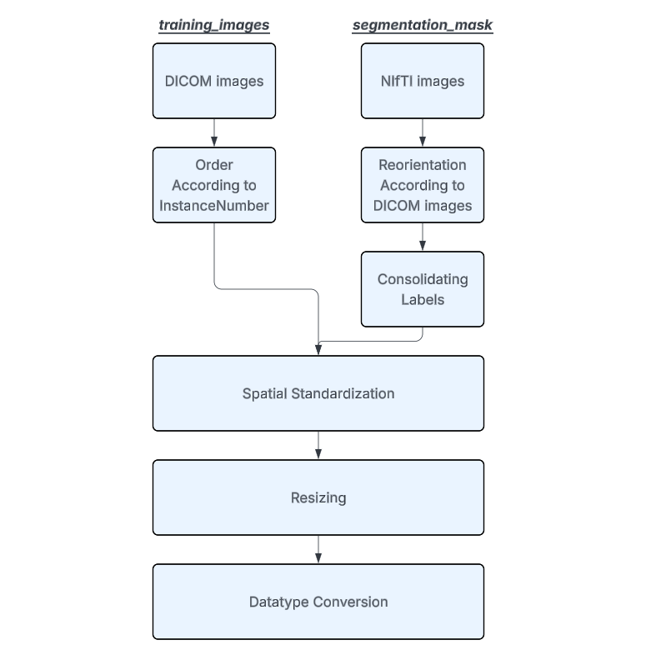

Figure 1: Data pre-processing pipeline

3.3 Experimental Design

The study investigated three main factors influencing U-Net-based [16] vertebral CT segmentation: pre-processing and augmentation, model architecture, and loss function selection. U-Net was selected as the base architecture due to its well-established effectiveness in medical image segmentation tasks [17]. Its encoder-decoder structure with skip connections enables the network to capture both high-level semantic features and fine-grained spatial details, which are both essential for accurate segmentation of small and complex anatomical structures such as vertebrae. Furthermore, U-Net has been widely adopted in vertebral segmentation literature, making it a suitable and well-justified baseline for this study [7][8][14] [15]. Each experiment was designed to isolate a single variable while keeping other conditions, including training configuration, pre-processing, and augmentation, constant to ensure fair comparisons

Experiment 1: Effect of Pre-processing and Augmentation
The first experiment evaluated how HU normalisation and data augmentation techniques affect segmentation performance and computational efficiency. A baseline 2D U-Net model with minimal pre-processing was compared against an enhanced 2D U-Net incorporating two additional components: HU normalisation and data augmentation. HU normalisation was applied by windowing and clipping the intensity range to [-200, 1800], which was selected to capture the relevant range of spinal tissue while suppressing irrelevant structures such as metal implants and surrounding soft tissue [18]. To ensure a fair comparison of computational efficiency, online augmentation was adopted rather than offline augmentation, meaning augmentations were applied randomly to each sample during training rather than generating additional data. This kept the dataset size identical across both models while introducing sufficient diversity to improve model generalisation. The augmentation pipeline was applied with an 30% probability, including horizontal flipping, small rotations (±15°), scaling (0.9–1.1), translations (±10%), intensity variations, Gaussian noise, gamma correction, and elastic deformations. These augmentations were selected to improve model robustness and generalisation by simulating realistic variations in vertebral anatomy, scanner differences, and patient positioning. Both models were trained for twenty epochs with a batch size of 64 using the Adam optimizer and a ReduceLROnPlateau scheduler, and segmentation quality was measured using Dice score, IoU, and accuracy.

Experiment 2: Effect of Model Architecture
The second experiment compared 2D, 2.5D, and 3D U-Net architectures to assess the impact of spatial context on vertebral segmentation. The 2D model processed single axial slices with an input tensor shape of (1, 512, 512), limiting spatial context though allowing large batch sizes. The 2.5D model used stacks of three adjacent slices with an input tensor shape of (3, 512, 512), providing partial volumetric context while maintaining feasible memory requirements. The 3D model operated on full volumetric inputs with an input tensor shape of (1, 64, 512, 512), capturing complete anatomical continuity though with increased computational cost and smaller batch sizes. All models shared the same pre-processing, augmentation, loss function (CrossEntropyLoss), learning rate, and optimizer settings. This experiment examined the impact of spatial context and the trade-offs between segmentation accuracy and computational efficiency.

Experiment 3: Effect of Loss Function
The third experiment focused on how different loss functions influence segmentation under severe class imbalance, as vertebral pixels constitute a small fraction of each CT slice compared to the background. A 2.5D U-Net was trained using four loss functions: CrossEntropy, Focal, Dice, and Dice + CrossEntropy. CrossEntropy served as the baseline, computing the average loss equally across all pixels regardless of class frequency. Focal loss addressed this limitation by down-weighting well-classified pixels and placing greater emphasis on hard-to-classify examples, encouraging the model to focus on the minority vertebral classes during training. Dice loss optimised the overlap between predicted and ground truth segmentation masks directly, making it less sensitive to class imbalance as it evaluates the proportion of correctly segmented regions rather than individual pixel counts. The hybrid Dice + CrossEntropy combination aimed to leverage the benefits of both functions, balancing pixel-level accuracy with robust segmentation of rare vertebral classes. All other training parameters, including pre-processing, augmentation, learning rate, optimizer, scheduler, and batch size, were kept constant. This design enabled direct evaluation of each loss function's effectiveness in addressing class imbalance and improving vertebral segmentation performance.

3.4 Experimental Setup
All experiments were conducted on the Rohan Cluster, a high-performance computing (HPC) system within the A2I2 HPC Cluster at Deakin University. Each experiment utilized a single node equipped with an NVIDIA V100 GPU, 100 GB of system RAM, and 40 CPU cores per task, providing sufficient computational resources to efficiently train U-Net models on volumetric vertebral CT data. The cluster’s VAST high-performance storage system enabled rapid access to large DICOM and NIfTI datasets, ensuring high-throughput input/output operations during training. Job scheduling and resource management were handled via the Slurm Workload Manager, allowing for reproducible and parallelized experiment execution. The models were implemented using the PyTorch deep learning framework with CUDA support for GPU acceleration, ensuring optimized training performance. This environment facilitated experiments spanning multiple model architectures, pre-processing strategies, and loss functions, while maintaining computational efficiency and reproducibility.

3.5 Evaluation Metrics

1 Segmentation Performance
Segmentation quality was evaluated using three widely used metrics: Accuracy, Dice Score, and Intersection over Union (IoU). These metrics provide complementary insights into overall correctness, overlap quality, and precision for multi-class segmentation tasks.
- Accuracy measures the proportion of correctly classified pixels across all classes. It is defined as:
$$Accuracy=\frac{TP+TN}{TP+TN+FP+FN}$$
where TP and TN are the true positive and true negative pixels, respectively, and FP and FN represent false positive and false negative pixels. While simple to compute, Accuracy can be misleading in highly imbalanced datasets, such as vertebral CT scans, where the majority of pixels belong to the background.
- Dice Score quantifies the overlap between the predicted mask P and the ground truth mask G. It is particularly sensitive to small structures and minority classes and is defined as:
$$Dice Score=\frac{2∣P∩G∣}{∣P∣+∣G∣}$$
A higher Dice Score indicates better boundary prediction and overlap between the predicted and ground truth segmentations, which is critical for accurate vertebra delineation.
- Intersection over Union (IoU) measures the ratio of the intersection to the union of predicted and ground truth masks:
$$IoU=\frac{∣P∩G∣​}{∣P∪G∣}$$
IoU is more stringent than Dice in penalizing false positives and provides a robust metric for multi-class segmentation evaluation. Together with Dice Score, IoU ensures both overlap quality and prediction precision are assessed.

2 Computational Efficiency
In addition to segmentation performance, computational efficiency was assessed to capture the practical feasibility of training different U-Net models on volumetric CT datasets. Metrics included Total Training Time(hours), Average RAM usage, Average GPU Memory consumption and CO2 emission.
- Total Training Time measures the wall-clock time required to train a model to completion, allowing comparison of overall computational cost across architectures and pre-processing strategies.
- Average RAM (GB) and Average GPU Memory (GB) track system memory and GPU memory utilization during training, which is critical for models with 3D or 2.5D volumetric inputs where high memory consumption can limit batch size and model scalability.
- CO₂ Emissions (kg) quantify the environmental impact of training deep learning models. CO₂ emissions were estimated from the total energy consumed E (in kWh) during training using:
$$CO2​ Emissions (kg)=E×CF$$
where CF is the carbon factor (kg CO₂ per kWh) for the electricity source. This metric highlights the sustainability implications of computationally intensive models and helps guide efficient model design.
This evaluation framework balances accuracy, overlap quality, computational efficiency, and resource usage, providing a comprehensive basis for comparing different segmentation models and training configurations in medical imaging tasks.

4 RESULTS

4.1 Experiment 1: Applying HU Normalisation and Augmentation
This experiment examined the impact of pre-processing and data augmentation on vertebral segmentation performance using a 2D U-Net with a ResNet34 encoder trained on the RSNA2022 dataset. Two configurations were compared: a baseline model with minimal pre-processing steps (E1-base), and an augmented model and HU normalisation and augmentation techniques (E1-augmentation).

Across all evaluation metrics, only marginal differences were observed between E1-base and E1-augmentation. Overall segmentation performance was nearly identical, with the baseline and augmented models achieving Dice scores of 0.2251 and 0.2208, and mean IoU values of 0.2137 and 0.2087, respectively. Pixel accuracy also remained almost unchanged (0.9939 vs. 0.9929), demonstrating that the applied pre-processing techniques does not improve segmentation on the RSNA 2022 dataset. In fact, the E1-base even performed better than the E1-augmentation at C2 when the Dice Score observed 2% higher.

From a computational perspective, the use of augmentation introduced measurable training overheads without altering hardware resource utilisation. The augmented configuration required an average of 16.2 hours for training, compared with 15.5 hours for the baseline model, representing a 4.6% increase. Energy consumption and carbon emissions during training were also slightly higher, with augmentation producing an additional 0.04 kg of CO₂ per complete training run. Despite these increases, CPU and GPU power consumption, as well as memory usage, remained nearly identical between the two configurations.
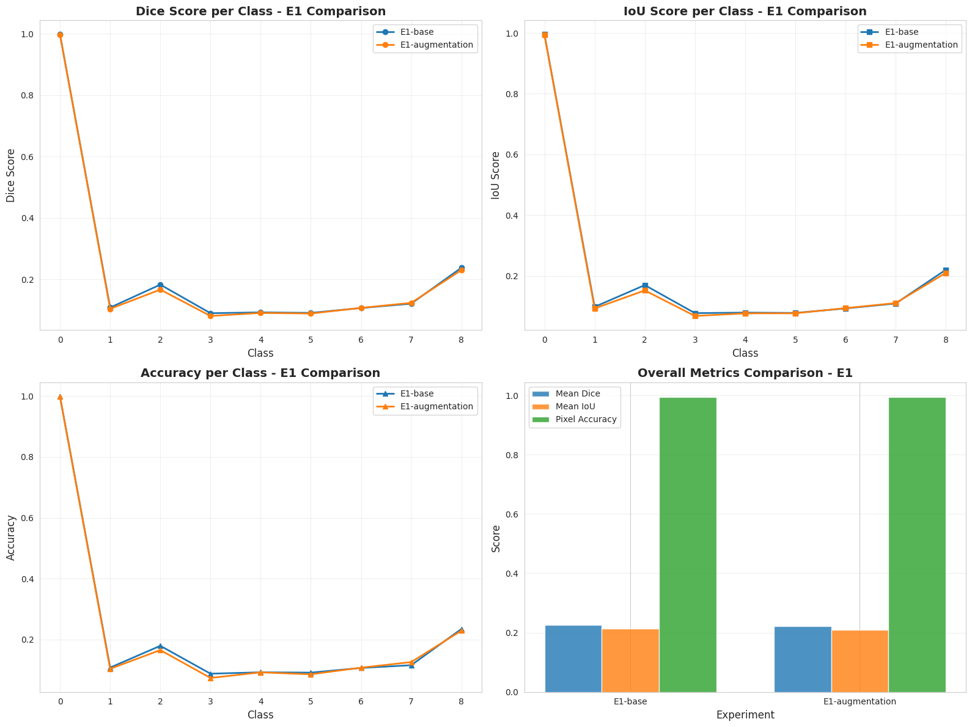

Figure 2: Class-wise segmentation performance in Experiment 1 (Accuracy, Dice, and IoU)
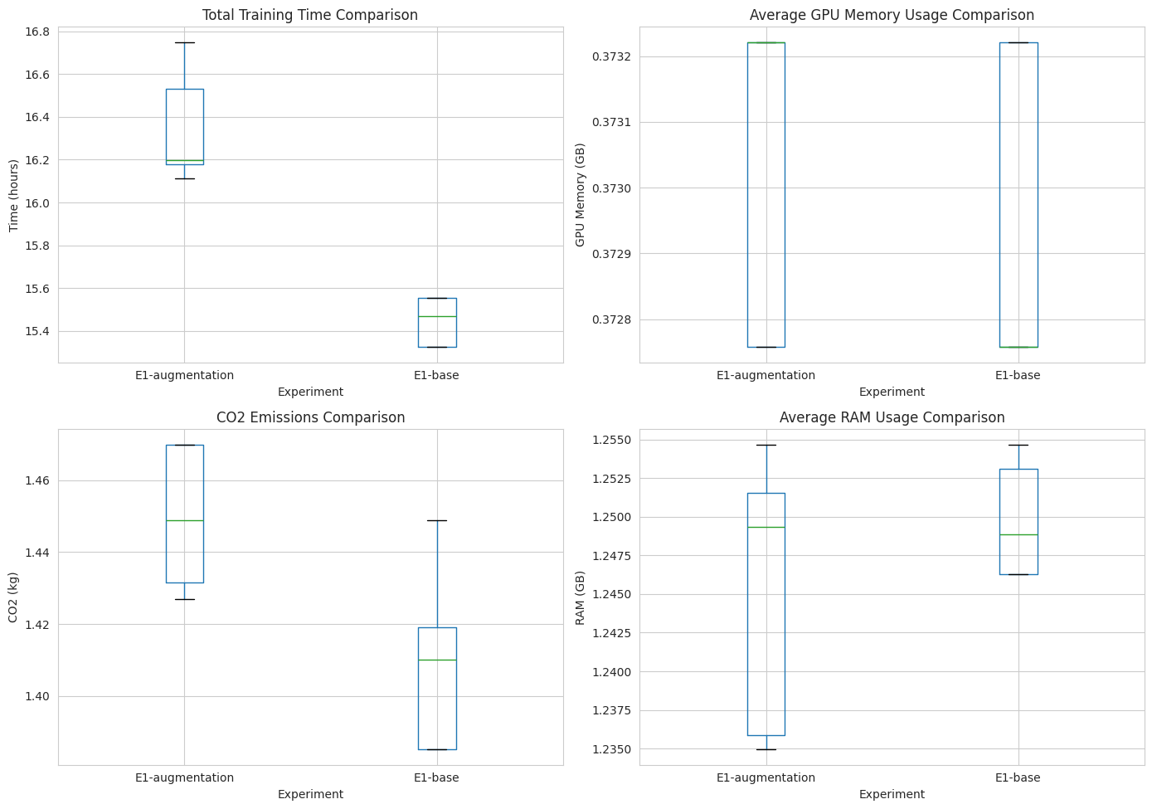

Figure 3: Computational efficiency metrics during training in Experiment 1

4.2 Experiment 2: Applying Different Model Architectures
In this experiment, the effect of different model architectures, including 2D (E2-base), 2.5D (E2-2.5D), and 3D (E2-3D) U-Net, was evaluated on vertebral segmentation performance. The analysis focused on segmentation accuracy, per-class performance, computational efficiency, and convergence behaviour.

The E2-3D model achieved the highest overall segmentation performance, with a mean Dice score of 0.2826, showing an improvement over the E2-base model, which achieved a Dice score of 0.2208. The E2-2.5D model offered only a modest gain over the 2D configuration with a Dice score of 0.2333. Similar trends were observed in mean IoU, with E2-3D achieving 0.2260 compared with 0.2089 for E2-base and 0.2219 for E2-2.5D. Class-wise analysis showed that the E2-3D model perform better than both E2-2D and E2-2.5D, particularly for C2–C6, with performance gaps of around 10% across metrics. The 2.5D model offered only minor improvements over 2D, though its performance remained consistently above the baseline for all vertebrae. Background segmentation remained near perfect across all architectures, with Dice scores exceeding 0.99, though the 3D model showed a slight reduction due to volumetric effects. Pixel-wise accuracy remained high across all models, with all exceeding 0.98, since the high accuracy of background class.

When comparing training time at the same number of epochs, the E2-base completed each epoch faster than the E2-2.5D model, taking a total of 16.35 hours for 20 epochs compared with 18.63 hours for 2.5D model. Despite this, E2-2.5D model converged faster, reaching convergence at 14 epochs in 13.11 hours, while 2D required 23 epochs and 18.84 hours. The 3D U-Net outperformed both models in terms of both total training and convergence time, completing 200 epochs in 5.26 hours and converging at 67 epochs in only 1.78 hours.

Average RAM usage was similar across models, with E2-base at 1.245 GB, 2.5D at 1.255 GB, and 3D at 1.316 GB. GPU memory consumption for E2-3D was lower than the other models, using 0.294 GB during training compared with 0.373GB GB for both 2D and 2.5D models. During convergence, however, the E2-3D required more epochs (67) to reach stability, resulting in much higher cumulative RAM and GPU usage with 88.16GB and 19.67GB. CO₂ emissions for training were lowest for E2-3D at 0.46 kg, compared with 1.66 kg for E2-2.5D and 1.6 kg for E2-base. These results indicate that the 3D model achieved the shortest training time in term of the whole training or convergence and producing the least environmental impact. However, the higher cumulative resource usage during convergence highlights the need to consider peak hardware demands when planning large-scale or memory-intensive experiments.

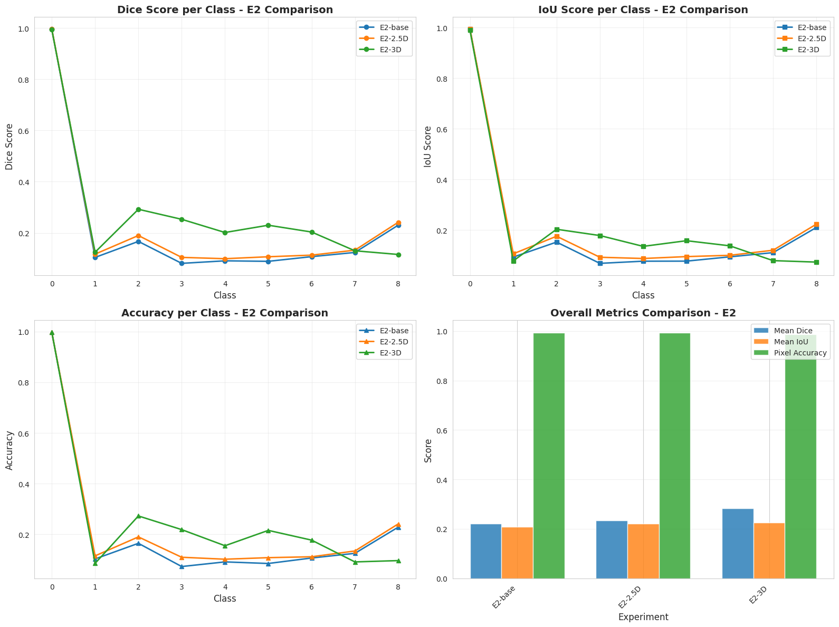

Figure 4: Class-wise segmentation performance in Experiment 2 (Accuracy, Dice, and IoU)

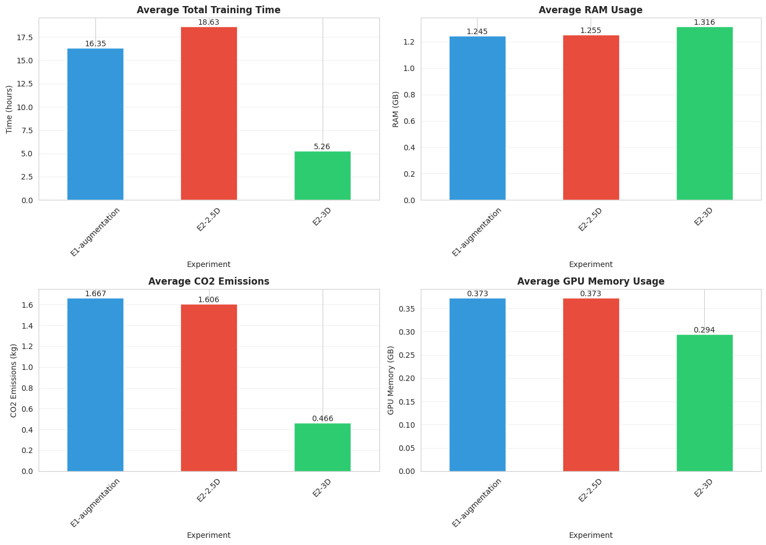

Figure 5: Computational efficiency metrics during training in Experiment 2

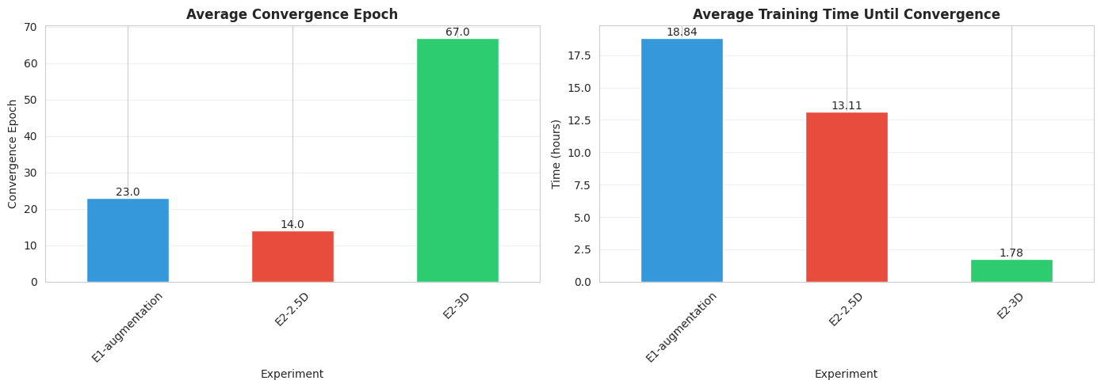

Figure 6: Convergence time in Experiment 2

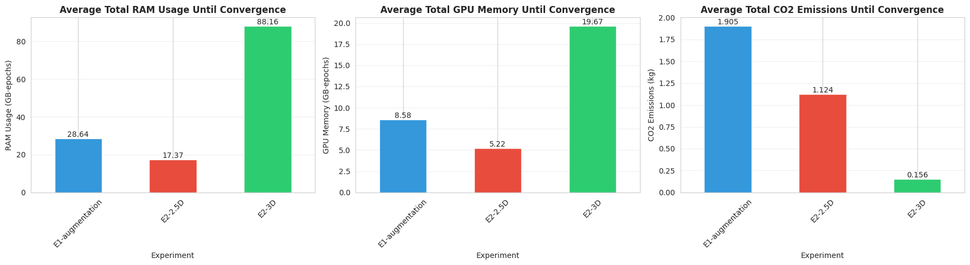

Figure 7: Computational efficiency metrics until convergence in Experiment 2

4.3 Experiment 3: Impact of Loss Function Selection on Training Dynamics and Segmentation Performance
This experiment investigated the effect of different loss functions on vertebral segmentation performance and training efficiency in the presence of severe class imbalance. Four loss functions were tested on the 2D U-Net architecture with ResNet34 encoder: Cross-Entropy Loss (E3-CE), Dice Loss (E3-Dice), Combined Cross-Entropy and Dice Loss (E3-CE-Dice), and Focal Loss (E3-Focal). The goal was to determine whether loss function selection could significantly improve model performance under extreme imbalance between background and vertebrae pixels.

Across all loss functions, performance differences were minimal. Mean Dice scores varied only within a narrow range from 0.2220 for E3-Focal to 0.2312 for E3-CE-Dice, representing a maximum improvement of 1.9% compared with E3-CE. Similarly, mean IoU ranged from 0.2037 to 0.2174, and pixel accuracy remained above 98.7% for all models. Overall, the discrepancy was minor, highlighting that loss function selection alone does not substantially affect performance when background dominance is extreme. Background segmentation remained excellent across all models, exceeding 99.3%, which further emphasizes that class imbalance dominated training outcomes.

Training time differences were small, with E3-CE-Dice requiring 19.8 hours compared with 18.6 hours for E3-CE, representing a 6.5% increase. E3-Dice and E3-Focal added minimal overhead compared with CE. Energy consumption and carbon emissions also showed negligible differences, with CO2 emissions ranging from 1.597 to 1.635 kilograms. Hardware utilization measurements indicated slightly higher GPU power for Dice loss, though memory usage differences remained minor and well within system limits.
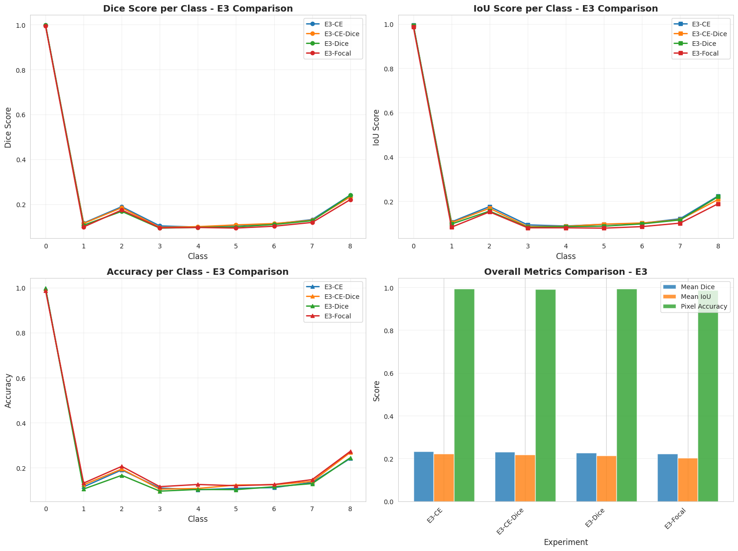

Figure 8: Class-wise segmentation performance in Experiment 3 (Accuracy, Dice, and IoU)

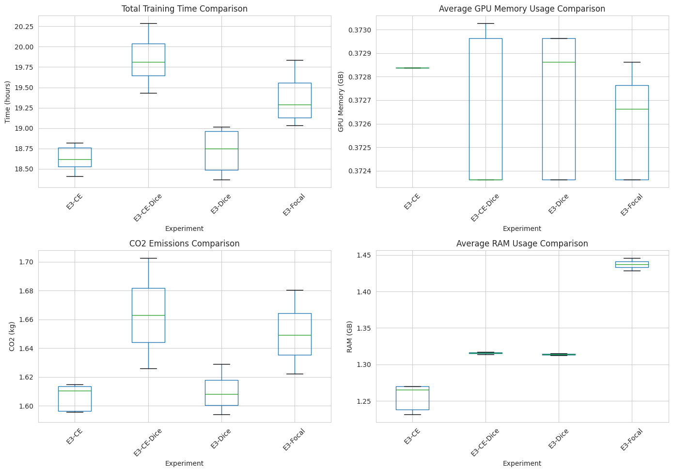

Figure 9: Computational efficiency metrics during training in Experiment 3

5 DISCUSSION

5.1 Discussion: Impact of HU Normalisation and Augmentation

Although HU normalisation and data augmentation are commonly applied in medical image segmentation to improve data quality and model generalisation, the results of Experiment 1 indicate that these techniques did not improve the vertebral segmentation performance on the RSNA 2022 dataset. Across all vertebral classes, Dice Score, IoU, and Accuracy remained consistently low, while the background class achieved near-perfect scores. There are two potential explanations may account for this outcome.

First, the core limitation may lie in the architectural design of the model. In this experiment, we used 2D U-Net as the baseline, which processes each axial slice independently without any awareness of neighbouring slices. Since the RSNA 2022 dataset is a 3D CT dataset, where each study is represented as a sequence of 2D axial slices, this slice-by-slice approach fails to capture the inter-slice spatial relationships inherent to vertebral structure. Consequently, preprocessing techniques such as HU normalisation and data augmentation, which only modify the appearance of individual slices, are insufficient to compensate for this fundamental lack of volumetric spatial understanding. To further investigate whether this architectural constraint is the underlying cause of poor segmentation performance, Experiment 2 explores 2.5D and 3D architectures that provide the model with better spatial context.

Second, severe class imbalance present in the RSNA 2022 dataset, where background pixels constitute over 97% of all pixels (Figure 10), might be also a potential problem. During training, the model optimises the loss function to minimise prediction error across all pixels. Cross-entropy loss, used in the baseline model, computes the average loss per pixel independently, treating each pixel equally regardless of its class. Therefore, the model tends to predict pixels as background, since doing so yields a low loss without needing to correctly identify any vertebral structure. Although HU normalization adjusts the intensity range of input slices and online data augmentation introduces variation in image appearance, neither technique addresses the core issue of class imbalance, as the ratio of background to vertebral pixels remains unchanged. To investigate whether this class imbalance is the underlying cause of poor vertebral segmentation, other loss functions that directly prioritises overlap with vertebral regions rather than pixel-wise accuracy is explored in Experiment 3.

While segmentation performance did not meet expectations, computational efficiency followed a predictable pattern. E1 augmentation model required longer training time due to additional CPU side processing during data loading and a higher number of epochs needed for convergence. Augmentation operations increase per epoch computation and slow the data pipeline, while GPU utilisation remains similar in both configurations as the model architecture and training parameters are unchanged.

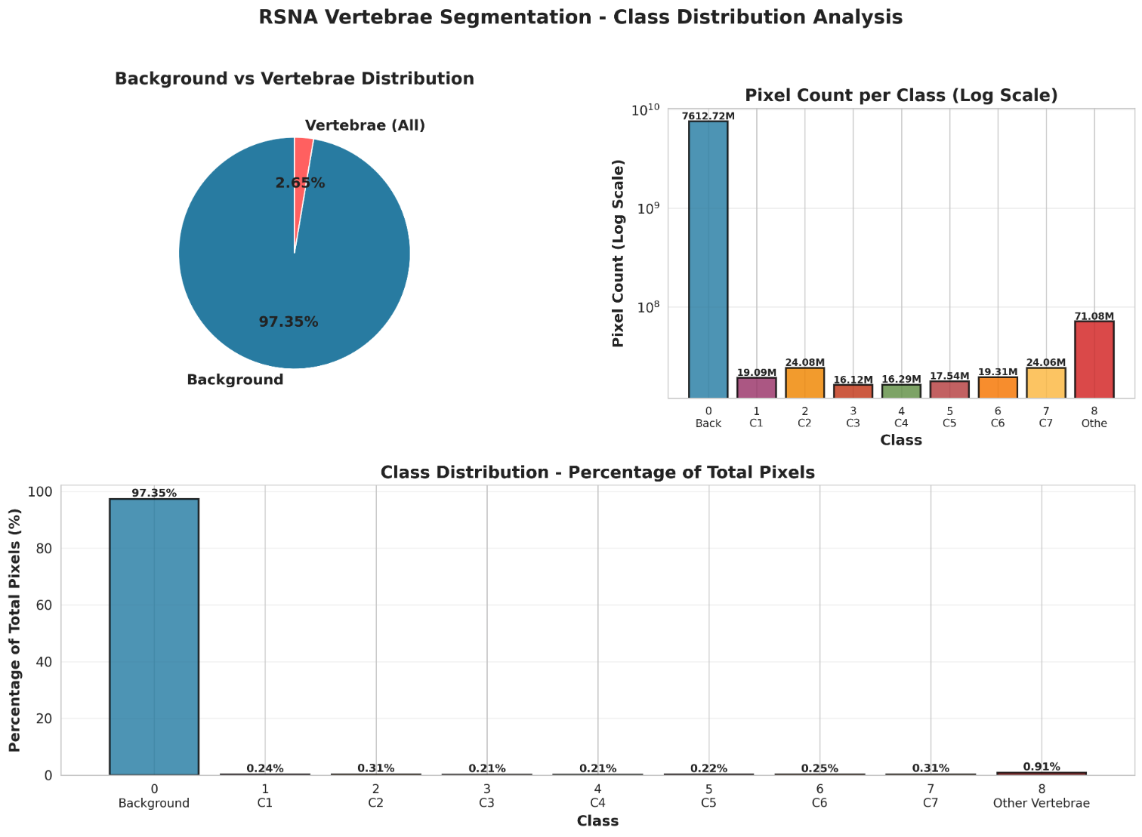

Figure 10: Class distribution in segmentation data of RSNA 2022

5.2 Discussion: Impact of Model Architecture on Segmentation Performance

The result of Experiment 2 demonstrates that spatial context is important for accurate vertebral segmentation in the RSNA 2022 dataset. The 3D model outperformed both 2D and 2.5D approaches across most classes, as it processes entire volumes simultaneously and captures the full three-dimensional anatomical structure. This volumetric context allows the network to learn inter-slice relationships, accurately detect complex boundaries, and extract features that span multiple slices, which are inherently limited in 2D or only partially available in 2.5D models. The 2.5D model provides only modest improvements over 2D, as incorporating information from adjacent slices offers some inter-slice context though remains insufficient to fully substitute for true three-dimensional processing. Despite these improvements from 3D model, the overall segmentation performance remains low, suggesting that architectural constraints alone do not fully account for the poor results, and other limitations such as class imbalance, data curation, and data sampling strategies still need to be considered

The 2.5D architecture explored in this study was inspired by the work of Kim et al. [12], who reported remarkable segmentation performance using a similar approach, achieving a Dice score of 100% and a validation accuracy of 99.91%. Their model follows a U-Net design with an EfficientNet-B5 encoder backbone pretrained on ImageNet, taking three consecutive slices as a 3-channel input and producing a 9-channel output representing individual vertebral labels. Despite being inspired by this approach, the 2.5D model in this study did not replicate the same level of performance, which is probably attributable to differences in experimental conditions.

From a computational perspective, the 3D U-Net demonstrates both high efficiency and environmental friendliness. Although it requires more epochs to converge, each epoch processes fewer total samples and benefits from volumetric operations optimized in the MONAI framework, resulting in faster overall training and reduced energy consumption.
However, the 3D model requires sufficient GPU memory and hardware support to handle full volumes, and cumulative resource usage over the convergence period is higher than per-epoch usage, making adequate computational resources essential to fully realize its performance advantages.

5.3 Discussion: Impact of Loss Function Selection

Results from Experiment 3 indicate that no loss function consistently perform better than the others. The observed performance differences are marginal and remain within a narrow range, indicating that loss function selection alone does not lead to substantial improvements in vertebral segmentation under the current experimental conditions. Notably, Dice loss and Focal loss, which are designed to prioritise minority classes during training, did not produce meaningful gains over standard cross-entropy loss. This suggests that severe class imbalance is not the primary cause of poor vertebral segmentation performance. This is further supported by the model predictions shown in Figure 11, where the models demonstrate their ability to distinguish between background and vertebrae regions, though struggle to differentiate between individual vertebral levels

Training efficiency metrics further support the conclusion that loss function selection plays a negligible role in overall computational performance. Training time, memory usage, energy consumption, and carbon emissions remain highly consistent across all experiments, reflecting the fact that loss computation represents only a small portion of the total training cost. Instead, the dominant contributors to computational load are the forward and backward passes of the network and data loading operations, which are identical across experiments due to the shared architecture and training configuration. Consequently, variations in loss function complexity have minimal effect on convergence speed or resource utilization.

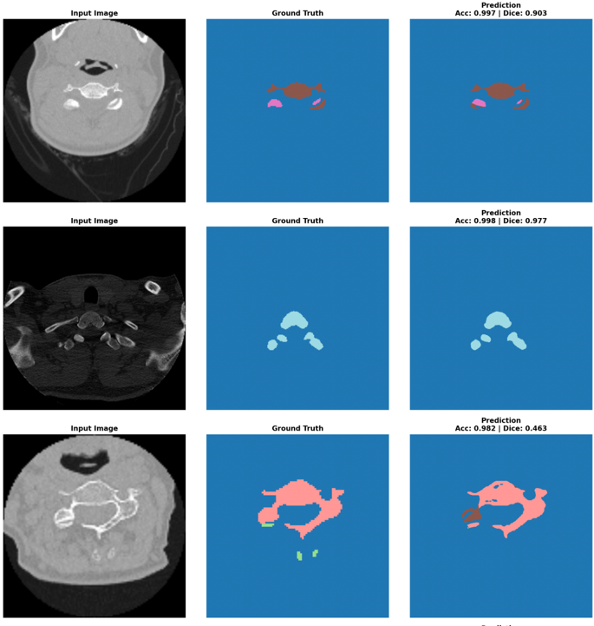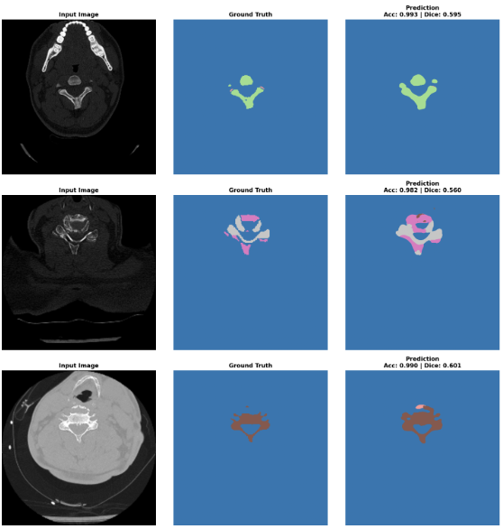
a) Dice Loss Function b) Cross Entropy Loss Function
Figure 11: Model Prediction of a) Dice Loss Function and b) Cross Entropy Loss Function

5.4 Future Work

Several directions remain open for future investigation. The 3D model architecture could be improved by addressing the variable number of slices across studies in the RSNA 2022 dataset, which requires careful consideration of model size and input handling strategies. To build a more accurate 3D model, additional scan-level properties such as 3D voxel size and slice thickness should be considered to ensure consistent volumetric representation across studies. This highlights the need for more thorough data curation and sampling strategies that account for these properties.

6 CONCLUSION

While the RSNA 2022 dataset provides the necessary annotations and scale to serve as a foundation for vertebral segmentation research, multi-class vertebral segmentation on this benchmark remains largely unexplored. Under RSNA 2022 challenging conditions, standard pre-processing choices such as HU normalisation and data augmentation had minimal impact on performance, and alternative loss functions alone were insufficient to mitigate pixel-level class imbalance. However, 3D U-Net approach demonstrated its potential by effectively capturing volumetric spatial context and inter-slice dependencies, suggesting a promising direction for future exploration. Future work should prioritise data curation and resampling techniques, as improving data quality is probably to be the most impactful step toward fully realising the potential of RSNA 2022 as a vertebral segmentation benchmark.
[1] “Cervical Spine (Neck): What It Is, Anatomy & Disorders,” Cleveland Clinic. Accessed: Mar. 18, 2026. [Online]. Available: https://my.clevelandclinic.org/health/articles/22278-cervical-spine
[2] J. H. McMordie, V. K. Viswanathan, and C. C. Gillis, “Cervical Spine Fractures Overview,” in StatPearls, Treasure Island (FL): StatPearls Publishing, 2025. Accessed: Jan. 07, 2026. [Online]. Available: http://www.ncbi.nlm.nih.gov/books/NBK448129/
[3] B. Tins, “Technical aspects of CT imaging of the spine,” Insights Imaging, vol. 1, no. 5–6, pp. 349–359, Oct. 2010, doi: 10.1007/s13244-010-0047-2.
[4] M. S. M. MD and E. P. BS, “Burnout in Radiology: Key Risk Factors and Promising Solutions | Diagnostic Imaging.” Accessed: Mar. 26, 2026. [Online]. Available: https://www.diagnosticimaging.com/view/burnout-in-radiology-key-risk-factors-promising-solutions
[5] C. S. Ahuja, J. H. Badhiwala, and M. G. Fehlings, “‘Time is spine’: the importance of early intervention for traumatic spinal cord injury,” Spinal Cord, vol. 58, no. 9, pp. 1037–1039, 2020, doi: 10.1038/s41393-020-0477-8.
[6] H. M. Lin et al., “The RSNA Cervical Spine Fracture CT Dataset,” Radiol. Artif. Intell., vol. 5, no. 5, p. e230034, Sep. 2023, doi: 10.1148/ryai.230034.
[7] A. Sekuboyina, J. Kukačka, J. S. Kirschke, B. H. Menze, and A. Valentinitsch, “Attention-driven deep learning for pathological spine segmentation,” presented at the Lecture Notes in Computer Science, 2018, pp. 108–119. doi: 10.1007/978-3-319-74113-0_10.
[8] G. Sha, J. Wu, and B. Yu, “Spinal fracture lesions segmentation based on U-net”.
[9] G. Sha, J. Wu, and B. Yu, “A Robust Segmentation Method Based on Improved U-Net,” Neural Process. Lett., vol. 53, no. 4, pp. 2947–2965, Aug. 2021, doi: 10.1007/s11063-021-10531-9.
[10] P. Chłąd and M. R. Ogiela, “Deep Learning and Cloud-Based Computation for Cervical Spine Fracture Detection System,” Electronics, vol. 12, no. 9, p. 2056, Apr. 2023, doi: 10.3390/electronics12092056.
[11] P. Sidpara, A. Agarwal, D. Swain, R. K. Gupta, A. Bhilare, and M. Upkare, “EfficientNet Convolutional Neural Network for Automated Cervical Spine Fracture Identification,” in 2024 6th International Conference on Computational Intelligence and Networks (CINE), Bhubaneswar, India: IEEE, Dec. 2024, pp. 1–6. doi: 10.1109/CINE63708.2024.10880887.
[12] D. Sutradhar, N. M. Fahad, M. A. Khan Raiaan, M. Jonkman, and S. Azam, “Cervical spine fracture detection utilizing YOLOv8 and deep attention-based vertebrae classification ensuring XAI,” Biomed. Signal Process. Control, vol. 101, p. 107228, Mar. 2025, doi: 10.1016/j.bspc.2024.107228.
[13] M. Yaseen, M. Ali, S. Ali, A. Hussain, A. Athar, and H.-C. Kim, “Deep Learning Based Cervical Spine Bones Detection: A Case Study Using YOLO,” in 2024 26th International Conference on Advanced Communications Technology (ICACT), Pyeong Chang, Korea, Republic of: IEEE, Feb. 2024, pp. 01–05. doi: 10.23919/ICACT60172.2024.10472013.
[14] D. Kim et al., “Cervical Spine Fracture Detection Through Two-Stage Approach of Mask Segmentation and Windowing Based on Convolutional Neural Network,” in 2023 International Conference on Platform Technology and Service (PlatCon), Busan, Korea, Republic of: IEEE, Aug. 2023, pp. 1–6. doi: 10.1109/PlatCon60102.2023.10255157.
[15] A. K. Pandey, K. Senapati, and G. P. Pateel, “CAEB7-UNet: An Attention-Based Deep Learning Framework for Automated Segmentation of C-Spine Vertebrae in CT Images,” IEEE Access, vol. 13, pp. 39051–39065, 2025, doi: 10.1109/ACCESS.2025.3546324.
[16] O. Ronneberger, P. Fischer, and T. Brox, “U-Net: Convolutional Networks for Biomedical Image Segmentation,” arXiv.org. Accessed: Mar. 27, 2026. [Online]. Available: https://arxiv.org/abs/1505.04597v1
[17] “Automatic medical image segmentation with u-net: A deep learning approach (review),” Int. J. Commun. Inf. Technol..
[18] K. Greenway, “Hounsfield unit | Radiology Reference Article | Radiopaedia.org,” Radiopaedia. Accessed: Mar. 27, 2026. [Online]. Available: https://radiopaedia.org/articles/hounsfield-unit

